Assignment 8



**Team members (CP6)**

Senthil Balaji Prakash

Christy Paulson

Rahul Kokkirala

Paulvin Peter

Praneeth Venugopal

**INFO8685 – ITBA Capstone project Prof. Nancy Engelhardt**

Date submitted: April 07, 2023

Word Count: 1821

**Table of Contents**

**Description of the problem to be solved** 4

**Executive Summary** 5

**List of team members and responsibilities** 6

**Competitive analysis findings** 7

**SWOT Analysis** 7

**PESTEL Analysis** 8

**Balanced Scorecard** 10

**To-be process flows** 11

**As-is process flows** 12

**Business Requirements** 13

**Solution requirements (functional and non-functional)** 14

**Potential solution options (incl “do nothing”)** 17

**Possible solution #1 – (new in-house streaming platform)** 17

**Possible solution #2 – (partnership with external streaming services)** 19

**Possible solution #3 – do nothing method** 20

**Evaluation criteria** 22

**ROI** 24

**Solution 1 (new in-house streaming platform)** 24

**Solution 2 (partnership with external streaming services):** 24

**Solution 3 (Do nothing)** 25

**Solution recommendation:** 25

**Implementation/Deployment Strategy** 25

**Phased Implementation Strategy:** 25

**Backout Strategy:** 26

**Deployment Plan:** 26

**Training Plan:** 27

**Reason for a Phased Implementation Strategy:** 27

**Test Strategy** 28

**Testing Stages:** 28

**Test Environment:** 28

**Test Cases:** 28

**Defect Management:** 28

**Signoffs:** 29

**Regression Testing:** 29

**Security Testing:** 29

**Risks Log** 30

**Solution 1:** 30

**Solution 2:** 31

**Solution 3:** 33

**Transition Requirements** 33

**Database design** 34

**APA References** 35

# **Description of the problem to be solved**

The problem the team of Scrutiny Consulting is trying to solve is that many people nowadays prefer to watch movies and TV shows from the comfort of their own homes rather than going to a movie theatre. Cineplex Inc. recognizes this trend and wants to adapt its business model accordingly by providing its customers with an online streaming service. Our team has been tasked with designing and building this platform from scratch, which involves creating a user-friendly interface, implementing robust security measures to protect customer data, ensuring reliable and fast video streaming, and integrating with existing Cineplex Inc. systems. We understand the importance of this project for Cineplex Inc. and are committed to delivering a high-quality streaming service that meets the needs of its customers while also meeting industry standards for security and performance.

In addition to these problems, the current market is highly competitive with several streaming platforms already established in the market. Thus, it is crucial to ensure that the platform offers unique features and provides an exceptional user experience to attract and retain customers. To address this, our team at Scrutiny Consulting will conduct extensive market research and engage with users to understand their preferences and expectations. This will enable us to tailor the platform to meet the specific needs of our target audience and stand out in the crowded market.

# **Executive Summary**

The creation and implementation of a new streaming platform for Cineplex Inc. have been proposed to expand the company’s offerings in the cinema space and to be more accessible to a larger group of audience. By developing a user-friendly, intuitive platform that is usable on a variety of devices, the project aims to offer Cineplex Inc. customers an unparalleled entertainment experience. Customers will have the opportunity to buy or rent new releases in addition to a wide selection of on-demand streaming movies, TV series, and other media on the platform.

In order to accomplish this, our team will make use of the latest software development processes and tools to create a platform that is resilient, scalable, and capable of handling huge levels of traffic and user interactions. We will collaborate closely with the Cineplex Inc. team to comprehend their special needs and take their suggestions into account as we construct the product. Customers will find it simple to search and watch their favourite content on the platform because it is designed with a modern, responsive user interface.

Making sure that the platform works seamlessly with Cineplex Inc's current systems and infrastructure, including its loyalty program and ticketing system, will be one of the project's major hurdles. To make sure the platform is compatible with Cineplex Inc.'s current technologies and is simple to maintain and support moving ahead, our team will work closely with the IT department.

Overall, we are certain that our team has the knowledge and proficiency required to offer a premium streaming service platform that will satisfy Cineplex Inc.'s requirements and surpass the expectations of its clients. We are eager to collaborate closely with the Cineplex Inc. team to complete this project successfully.

# **List of team members and responsibilities**

* + - 1. **Senthil Balaji Prakash – Project Manager:**
* Work with stakeholders to define the scope of the project, including the objectives, deliverables, and success criteria.
* Develop a detailed project plan that includes timelines, resources, and budgets.
* Ensuring that the project team has the resources they need to complete the project, including personnel, equipment, and funding.
* The PM is responsible for identifying, assessing, and managing project risks.
* Ensuring that all project stakeholders are kept informed of project progress and any issues that arise.
* Make sure that all the project deliverables are completed on time, within budget, and to the satisfaction of the stakeholders.

1. **Rahul Kokkirala – Associate Project Manager:**

* Assisting the project manager in the day-to-day management of the project, including scheduling meetings, tracking progress, and managing project documentation.
* Help and assist the project manager in developing the project plan.
* Work with the project team to coordinate project activities and ensure that all tasks are completed on schedule.
* Track the progress of the project and report on any issues or delays to the project manager.
* Assist the project manager in closing out the project, including documenting lessons learned and conducting a final project review.
* Facilitate project meetings and create status reports.

1. **Paulvin Peter, (4) Praneeth Venugopal,**

**(5) Christy Paulson - Business Analysts:**

* Support the project team by providing research, data analysis, and documentation support.
* Assist in gathering and documenting business and system requirements from stakeholders.
* Conduct research to gather information on industry trends, competitor activity, and customer needs.
* Analyze data to identify patterns and trends, and to support decision-making.
* Create documentation such as business requirements documents, process flow diagrams, and user stories.
* Assist with creating project timelines, managing project risks and issues, and facilitating project meetings.
* Communicate with Stakeholders and users for additional information and to keep them informed.

# **Competitive analysis findings**

Based on the analysis carried out, the following are our findings, in the form of a SWOT analysis, a PESTEL analysis and a balanced scorecard

## **SWOT Analysis**

**Strengths**

* Cineplex Inc. is one of the leading entertainment sectors in Canada with a significant number of sites and a strong brand.
* Cineplex Inc. has a lot of competitors which include AMC, Landmark Cinemas and Empire Cinemas in the theatre chain, the facilities such as VIP seating, food and beverages play a major role to let Cineplex Inc. have a stronghold on the industry.
* Online movie ticket booking is another strength of Cineplex Inc. The user interface of Cineplex Inc.’s online ticketing system is so user-friendly and thus it attracts customers to book. This gives Cineplex Inc. a major competitive advantage over its competitors.
* Presence in various segments like entertainment & cinemas, media, and amusement & leisure is a major strength because no other competitors have these amenities.

**Weaknesses**

* Due to the wide range of locations and the premium amenities provided for improving the customer experience, the overhead cost will increase the pricing of tickets. This can pose a huge weakness for Cineplex Inc.
* The next weakness deals with the pandemic. It moved customer preferences from theatre to streaming devices, and the business of theatrical cinema has been largely impacted.
* Cineplex Inc. has been using existing and dated supply chain systems. This results in added expenses associated with creating a new supply chain and logistics network.

**Opportunities**

* Cineplex Inc. may be able to capitalize on the growing popularity of IMAX and other premium movie-going experiences.
* New online platforms can be implemented and the existing ones can be improved to elevate the customer experience.
* With the recent boom in social media influencer campaigns, collaborations can be made with online influencers and new services can be marketed in an efficient and user-friendly way.

**Threats**

* Changes in laws or taxes pertaining to the operation of movie theatres may have an effect on Cineplex Inc.
* Rapid technological improvements in the market, for instance, projection, and audio technologies can have a drastic impact on the business of Cineplex Inc.

## **PESTEL Analysis**

**Political**

* Cineplex Inc will be impacted by the regulations related to the operation of movie theatres and the entertainment industry like limiting movie theatres to 50 percent capacity and social distancing of two meters during the COVID Pandemic, thus the company can be impacted by the changes in the creative sector.

**Economic**

* Changes in consumer buying patterns and economic downturns in the country will have a severe impact on the company.
* Cineplex can also be affected by tariffs and tax changes by the government, for example, SK Regina region has around 15% Total Tax Rate but from Oct1 2022 the government is increased the Provisional Sales Tax by an additional 6% on the ticket sales which is now 21%.

**Social**

* Changes in Consumer Preferences will have an impact on the Company such as watching movies at home or online.
* Popularity of certain genres among people may force the Company to show more of those types of films in order to attract the audience.

**Technological**

* Changes in Technology such as the development of new Projections, Sound Systems will have a direct impact on the Cineplex because the audience looks for a better experience.
* Cineplex Inc may be impacted by the changes in the way people purchase tickets such as online booking or using rewards apps.

**Environmental**

* The Cineplex Inc may be impacted by the changes in the weather and natural disasters.
* New Environmental Regulations on movie industries such as adopting sustainable energy resources (Regular Bulbs to LED Lighting can save 50% of energy and installing Solar panels)

**Legal**

* Cineplex can be impacted by the changes in the laws and regulations related to the environment industry such as health and safety laws, Discrimination, and harassment laws.
* Changes in the copyright and IP Rights laws will also affect Cineplex because they have to make sure that they have rights to use the media content otherwise they have to pay for using copyrighted content.

## **Balanced Scorecard**

**STRATEGY**

# 

# **To-be process flows**

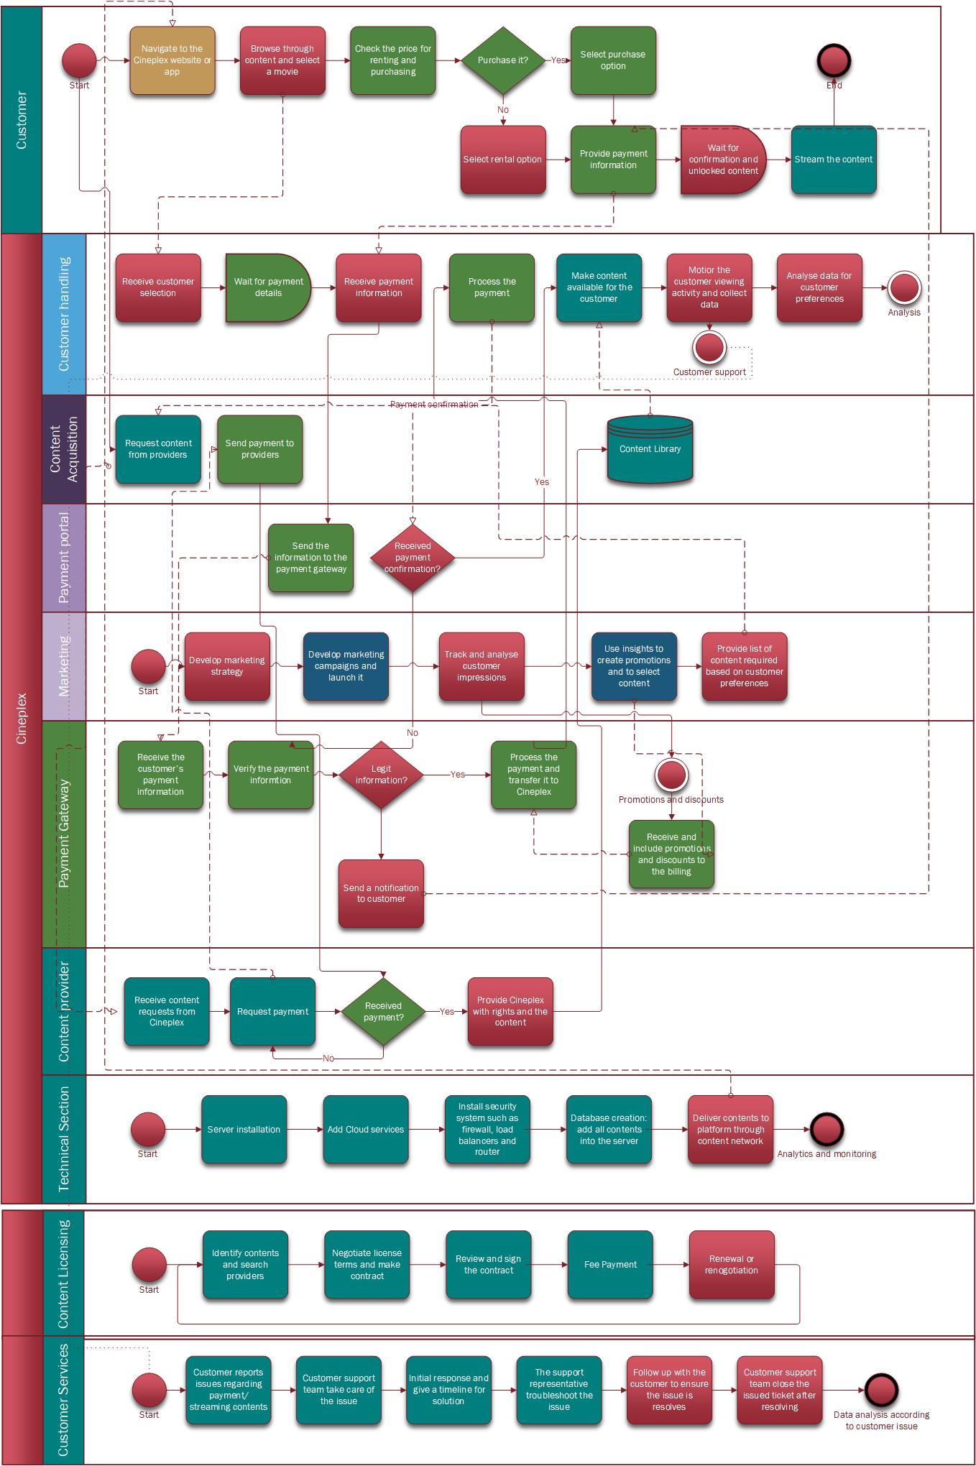

# **As-is process flows**

C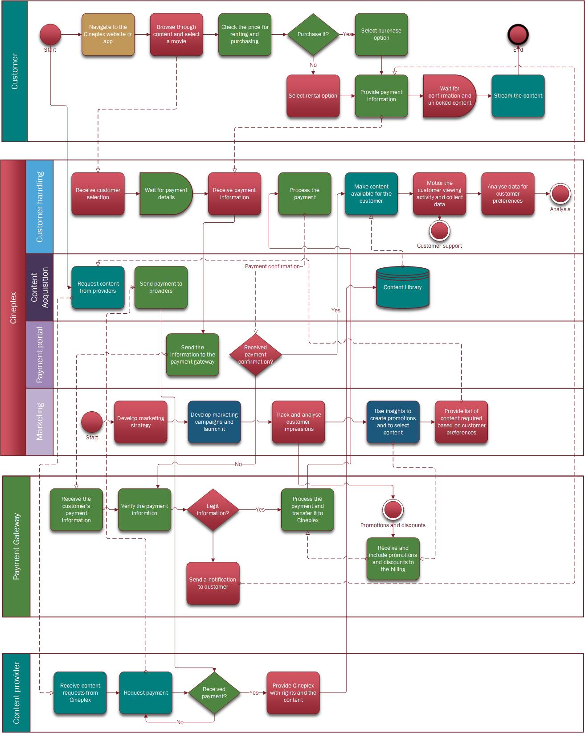

# **Business Requirements**

|  |  |  |
| --- | --- | --- |
| **ID** | **Business requirement description** | **Priority** |
|  |
| 1 | Cineplex will need to build a large library of movies and TV shows to attract the users, acquiring the necessary rights to stream the content, either through licensing agreements with content owners or by acquiring the rights to the content directly. | High |  |
|  |
| 2 | The online streaming platform must be user-friendly and easy to navigate. Cineplex should consider implementing features such as rating and reviewing systems, and playlists to enhance the user experience. | Medium |  |
|  |
|  |
| 3 | The online streaming platform must be secure and protect user's personal information and data by implementing measures to protect against hacking and piracy. | High |  |
|  |
|  |
| 4 | Need to ensure that the online streaming platform complies with all relevant laws and regulations, including those related to content licensing, and data privacy. | High |  |
|  |
|  |
| 5 | Cineplex needs to determine the best monetization model for the online streaming platform, such as subscription-based or pay-per-view. You will also need to implement a payment system that allows users to purchase access to your content library. | High |  |
|  |
|  |
|  |
| 6 | As the online streaming platform grows, Cineplex will need to ensure that it can scale to meet the increasing demand. This includes ensuring that the technology stack can handle the increased traffic and data storage requirements | Low |  |
|  |
|  |
| 7 | The payment processing for the service should be secure and reliable, and allow for integration with existing payment systems. | High |  |
|  |
| 8 | The service should offer customer support through various channels, and the availability of customer support should be ensured. | Low |  |
|  |
| 9 | The service should be available 24/7. | Medium |  |
|  |
| 10 | Develop and implement a comprehensive marketing strategy to promote the new streaming service to potential customers | Low |  |
|  |
| 11 | Ensure compatibility with a wide range of devices and platforms, including desktops, laptops, smartphones, and televisions | Low |  |
|  |
| 12 | Implement user account management features, including account creation, password reset, and profile updates | Medium |  |
|  |
| 13 | Implement a recommendation engine to suggest movies and events to customers based on their viewing history and preferences | Low |  |
|  |
| **ID** | **Business requirement description** | **Priority** |  |
| 14 | Implement disaster recovery and backup mechanisms to ensure high availability and data security | High |  |
|  |
| 15 | Implement search and filtering features to allow customers to easily find the movies and events they are interested in | Low |  |
|  |

# **Solution requirements (functional and non-functional)**

|  |  |  |  |  |  |
| --- | --- | --- | --- | --- | --- |
| **Type** | **Section** | **RIN** | **Requirement Description** | **Priority** | **Notes** |
| Functional requirements | User Management | 1 | 1. The user will be able to create an account and log in to the Pay-Per-View streaming platform. 2. Users will be able to see their login history. | High | User can be logged in only on two devices simultaneously |
| Content Management | 2 | 1. Users will be able to filter content on the PPV streaming service based on category, language, and rating. 2. Users will be able to look for particular movies or events from a broad selection of films as well as non-movie options including live sporting events, opera performances, and concerts. | Medium | Movies will be segregated based on genres. |
| Streaming Playback | 3 | 1. Users will be able to start, pause, and continue playing through the streaming service. 2. Users will have access to high definition (HD) streaming of movies and events. 3. The consumers of the Pay-Per-View streaming service will be able to seek back or ahead in time | High | User cannot download any content from the platform. |
| Payment | 4 | 1. The payment gateway will support several payment options, such as PayPal and credit cards. 2. A secure payment mechanism will be integrated with the streaming service. | High | If transaction fails customer will get refund with in 5-7 business days |
| Functional requirements | Functionality | 5 | 1. Pricing details for each film or event will be available to consumers. 2. Without committing to a lengthy subscription, customers will be able to buy or rent specific movies or events. | High |  |
| Non-functional requirements | Security | 6 | 1. The user authentication and authorization procedures used by the streaming service will be secure. 2. Data protection and payment processing security will be provided by the streaming provider. | High |  |
| Compatibility | 7 | 1. A large number of users will be supported by the streaming service. 2. The streaming service’s user interface will be quick and responsive. | High | Platform will be able to support future modifications and changes |
| Scalability | 8 | 1. The streaming service will feature both horizontal and vertical scaling capabilities. 2. The streaming service will be built to support future growth in both user and content. | High |  |
| Reliability | 9 | 1. With little downtime for maintenance, the streaming service will be accessible around-the-clock. 2. In case of system problems, the streaming service must have a disaster recovery strategy. | High |  |

# **Potential solution options (incl “do nothing”)**

## **Possible solution #1 – (new in-house streaming platform)**

**High-Level Design**

* Cineplex Canada's development team will be building an in-house streaming platform using the company's resources.
* The platform will have a modern and user-friendly interface which will ensure seamless streaming experiences across devices.
* Open-source technologies will be utilized to ensure scalability and maintainability.
* Content management, payment processing, user management, and video streaming will be integrated into the platform's design as they are essential.

**Low-Level Design**

* The platform will be designed to offer a wide range of content, including movies, TV shows, and original programs.
* The platform will be optimized for high-quality video playback, with support for 4K, HDR, and other advanced video formats.
* To ensure security and protect user privacy, the platform will incorporate robust encryption and data protection mechanisms.
* The platform will be designed to integrate with existing Cineplex Canada systems, such as the company's loyalty program and mobile app.
* The development team will conduct extensive testing to ensure the platform is stable and reliable, with minimal downtime or performance issues.
* Ongoing maintenance and support will be provided to ensure the platform remains up-to-date and continues to meet user needs.
* The platform will be designed with scalability in mind, allowing it to handle increasing levels of traffic and user demand over time.

**Impact Analysis**

Positive Impacts:

* Cineplex Canada will have full control over the design, features, and functionalities of the platform, enabling the company to offer a unique streaming experience to its customers.
* The platform can be customized to cater to the specific needs of Cineplex Canada's customers, which may lead to increased customer satisfaction and loyalty.
* The company can potentially generate new revenue streams by offering premium content and subscription-based services on the platform.
* Developing an in-house platform can lead to increased innovation and knowledge transfer within the company's development team.

Negative Impacts:

* Creating an in-house streaming platform requires a significant investment of time, effort, and resources, which may strain the company's budget and resources.
* The development team may require additional expertise, and expanding the team can lead to increased costs in the long run.
* The development and maintenance of the platform require ongoing investment, and the platform must be regularly updated to keep up with technological advancements.

**Out of Scope**

* Content creation process not included in this solution
* Content licensing and acquisition handled separately.

## **Possible solution #2 – (partnership with external streaming services)**

**High-Level Design**

Integration with existing streaming platforms - Cineplex will collaborate with third-party platforms such as Netflix and Amazon Prime to provide seamless streaming services and enhance user experience.

**Low-Level Design**

The development team will select the most appropriate third-party platform to integrate with the internal and external systems, including content management, data management, and user accounts. This will enable easier integration, extended support, and maintenance.

**Impact Analysis**

Positive Impacts:

* Partnering with existing streaming platforms can potentially provide Cineplex Canada with a new revenue stream with minimal investment and effort.
* The company can offer a wider range of content to its customers without the need for content acquisition or licensing.
* Integrating with an established platform can potentially increase the company's reach and brand recognition.

Negative Impacts:

* Partnering with existing streaming platforms means that Cineplex Canada will have less control over the platform's design, features, and functionalities, potentially leading to a less unique user experience.
* There is a risk that the company's customers may prefer other streaming platforms over Cineplex Canada's offering.
* The company will be subject to the rules and regulations of the partnered platform, which may impact the company's ability to offer certain services or content.

**Out of Scope**

The legal and financial aspects of partnering with a third-party streaming platform, such as content licensing and revenue sharing, are not included in this solution. These issues will be addressed separately.

## **Possible solution #3 – do nothing method**

**High-Level Design**

The do-nothing method involves maintaining the current cinema business without implementing a PPV platform.

**Low-Level Design**

No changes would be made to the current system. Customers would continue to purchase tickets through the existing website and mobile apps and watch movies in theatres.

**Impact Analysis**

The main impact of the do-nothing method is that the company would miss out on potential revenue and market share gains by not implementing a PPV platform. However, the company would not need to allocate resources to develop, maintain and market the PPV platform.

Positive impacts:

* No additional investment is required in terms of the development, maintenance, and marketing of the PPV platform
* Existing cinema business can continue as is, without any disruptions
* No need to hire additional staff to manage the PPV platform

Negative impacts:

* Missing out on potential revenue and market share gains from the PPV platform
* May fall behind competitors who offer both in-theatre and online viewing options
* **Customers may prefer the convenience of a PPV platform over going to the theatre**

**Out of Scope**

Risk and mitigation strategies are not applicable for this option as there are no changes being made.

# **Evaluation criteria**

* Cost: The cost of each solution will be evaluated, including upfront costs, ongoing maintenance costs, and potential cost savings or revenue gains.
* Timeframe: The timeframe for implementing each solution will be evaluated, including the estimated time required for development, testing, and deployment.
* User Experience: The user experience will be evaluated for each solution, including ease of use, accessibility, and overall satisfaction.
* Scalability: The scalability of each solution will be evaluated, including the ability to handle increasing traffic and user demand over time.
* Control and Customization: The level of control and customization available for each solution will be evaluated, including the ability to make changes and updates as needed.
* Revenue Potential: The revenue potential of each solution will be evaluated, including the potential for increased sales and revenue streams.
* Integration with Existing Systems: The ease of integration with existing systems and processes will be evaluated for each solution, including compatibility with current technology and software.
* Risk and Mitigation: The potential risks associated with each solution will be evaluated, along with proposed mitigation strategies and contingency plans.

|  |  |  |  |
| --- | --- | --- | --- |
| **Evaluation Criteria** | **Solution #1 - New In- house Streaming Platform** | **Solution #2 - Partnership with External Streaming Services** | **Solution #3 - Acquisition of Existing Streaming Platform** |
| Cost | High upfront and ongoing costs | Low upfront and ongoing costs, revenue-sharing model | High upfront cost, ongoing maintenance cost |
| Timeframe | Long development and testing time | Short development and testing time | Short development and testing time |
| User Experience | High degree of control and customization | Limited control and customization | Limited control and customization |
| Scalability | Designed for scalability | Scalability depends on the selected external platform | Designed for scalability |
| Control and Customization | High degree of control and customization | Limited control and customization | Limited control and customization |
| Revenue Potential | Potential for new revenue streams | Potential for new revenue streams | Immediate revenue streams |
| Integration with Existing Systems | High degree of integration with existing systems | Integration with existing systems varies by platform | High degree of integration with existing systems |
| Risk and Mitigation | Delays and cost overruns, technical difficulties | Risk of customer preference for other platforms, contract termination risk | Integration challenges, platform obsolescence risk |

# **ROI**

## **Solution 1 (new in-house streaming platform)**

The initial investment for developing the platform will be close to $10 million, with the annual maintenance costs being $1 million, we can calculate the ROI over a period of 5 years:

#### Total Investment = $10 million (initial investment) + $5 million (5 years of maintenance costs) = $15 million

Using the forecasted generation of revenue over 5 years is an average of $5 million in revenue per year through subscription fees, premium content sales, and other sources, we can calculate the total revenue generated over 5 years:

#### Total Revenue = $5 million (annual revenue) x 5 years = $25 million

Therefore, the ROI for the platform would be:

ROI = (Total Revenue - Total Investment) / Total Investment x 100% ROI = ($25 million - $15 million) / $15 million x 100%

**ROI** **=** **67%**

## **Solution 2 (partnership with external streaming services):**

The ROI for partnering with external streaming services will depend on various factors such as the revenue generated, cost savings, and customer retention. We can estimate the ROI as follows:

* If Cineplex charges a subscription fee of $10 per month, and assuming 1 million users subscribe to the service, the revenue generated per year would be $120 million.
* Assuming that the partnering platform incurs a cost of $5 per user per month for integration, maintenance, and support, the total cost would be $60 million per year.
* Assuming a customer retention rate of 80%, which means that 200,000 customers leave every year, the cost of acquiring new customers would be $20 million per year.
* With a profit margin of 25%, the net profit generated from the partnership would be $15 million per year.

Based on these numbers, the ROI is as follows:

ROI = (Net Profit / Cost of Investment) x 100 ROI = ($15 million / $60 million) x 100

**ROI** **=** **25%**

## **Solution 3 (Do nothing)**

As we are not doing anything in this method, the ROI will be 0.

# **Solution recommendation:**

Based on the research carried out, it was found that the in-house streaming platform design allows the company to have complete control over the platform's features, functionalities, and user experience. This can lead to increased customer satisfaction and loyalty, potentially generating new revenue streams through premium content and subscription-based services. However, this design requires a significant investment of time, effort, and resources, which may strain the company's budget and resources. It also requires ongoing investment in maintenance and updates to keep up with technological advancements.

# **Implementation/Deployment Strategy**

## **Phased Implementation Strategy:**

The approach involving phased implementation is proposed to facilitate a smooth transition to the new platform while minimizing service interruptions.

* Phase 1: The focus will be on developing key features required for our client; these include user management, content management, payment processing, as well as video streaming capabilities. Rigorous testing and quality assurance processes are expected to follow resulting in a stable and reliable platform at launch.
* Phase 2: Launch the platform to a limited audience, such as Cineplex employees. Feedback can be collected alongside analyzing real-world performance factors of our trial-run staged process.
* Phase 3: Gradually roll out the platform to select customers, such as loyalty program members. Feedback from this phase will help us meet specific customer needs while ensuring maximum stakeholder satisfaction.
* Phase 4: Full platform launch to the public. This commences after successfully rolling out all the phases. Consequently, we will identify all crucial hardware and software elements needed for the platform's functionality while also developing precise schedules during which these parts will be secured and installed.

## **Backout Strategy:**

In case of unforeseen issues during the phased implementation, a backout strategy will be in place to revert to the previous system and minimize the impact on users.

The backout plan will involve identifying key milestones and points of no return, ensuring that data is backed up regularly, and establishing a clear communication plan to keep stakeholders informed throughout the process.

## **Deployment Plan:**

* The deployment plan will involve identifying the specific hardware and software components required for the platform and the timelines for their procurement and installation.
* The deployment plan will also include a communication strategy to keep stakeholders informed of the progress of the deployment and any changes that may affect them.
* The deployment plan will outline the specific roles and responsibilities of team members involved in the deployment process, including developers, testers, project managers, and stakeholders.

## **Training Plan:**

* A training plan will be developed to ensure that all stakeholders involved in the platform, including employees and users, have the necessary skills and knowledge to use the platform effectively.
* The training plan will include onboarding materials, user manuals, and video tutorials to help users navigate the platform's features and functionalities.

## **Reason for a Phased Implementation Strategy:**

A phased implementation strategy provides several benefits, including reducing the risk of service disruption, allowing for better testing and quality assurance, and enabling stakeholders to adapt to the changes gradually.

The platform's development team can also use the feedback gathered during each phase to improve the platform's features and functionalities before launching it to a broader audience.

# **Test Strategy**

## **Testing Stages:**

* Unit Testing: Testing individual components of the platform to ensure they are functioning as expected.
* Integration Testing: Testing the integration of different components of the platform to ensure they are working together correctly.
* System Testing: Testing the complete system to ensure it meets the functional and non-functional requirements.
* User Acceptance Testing: Testing the platform with real users to ensure it meets their expectations and requirements.

## **Test Environment:**

* A separate testing environment will be set up to ensure that testing does not affect the live platform.
* The testing environment will be identical to the production environment to ensure accurate testing results.

## **Test Cases:**

* Test cases will be developed for each testing stage, covering all functionality and requirements of the platform.
* Test cases will be reviewed and approved by the relevant stakeholders before testing begins.

## **Defect Management:**

* + - Defects will be logged, tracked, and managed using a dedicated defect-tracking system.
    - Defects will be prioritized based on their severity and impact on the platform.
    - Defects will be assigned to the relevant team members for resolution, and regular updates will be provided on their progress.

## **Signoffs:**

* + - A signoff process will be implemented to ensure that each testing stage is completed successfully before moving on to the next stage.
    - Stakeholders will review and approve the results of each testing stage before signing off to proceed to the next stage.

## 

## **Regression Testing:**

* + - Regression testing will be conducted after each change or update to the platform to ensure that existing functionality has not been impacted.
    - Regression testing will be performed using automated testing tools to save time and effort.
    - Performance testing will be conducted using simulated traffic and user load, and performance metrics will be tracked and analyzed.

## **Security Testing:**

* + - Security testing will be conducted to ensure the platform is secure and user data is protected.
    - Security testing will be performed using specialized tools and techniques to identify vulnerabilities and potential risks.

# **Risks Log**

## **Solution 1:**

|  |  |  |  |
| --- | --- | --- | --- |
| **Risk Description** | **Impact** | **Probability of Occurrence** | **Mitigation** |
| User Adoption Risk: The platform may suffer from low user adoption due to limited content or poor user experience. | **High** | **Medium** | Offer a wide range of high- quality content and ensure an intuitive and engaging user experience. |
| Budget Risk: The project may exceed the allocated budget due to unexpected expenses. | **High** | **Medium** | Develop a detailed project plan and budget, and regularly review progress to adjust the plan as needed. |
| Data Breach Risk: The platform may experience a data breach, potentially leading to the loss of user data and trust. | **High** | **Low** | Incorporate robust encryption and data protection mechanisms to ensure security and protect user privacy. |
| Compatibility Risk: The platform may not be compatible with all devices and browsers. | **Medium** | **High** | Conduct extensive testing to ensure compatibility with all major devices and browsers. |
| Third-Party Integration Risk: The platform may not integrate seamlessly with existing Cineplex Canada systems, such as the company's loyalty program and mobile app. | **Medium** | **Medium** | Design the platform to integrate with existing systems, and conduct thorough testing to ensure seamless integration. |
| Performance Risk: The platform may experience performance issues or downtime during high- traffic periods. | **Medium** | **High** | Design the platform with scalability in mind, allowing it to handle increasing levels of traffic and user demand over time. |

## **Solution 2:**

|  |  |  |  |
| --- | --- | --- | --- |
| **Risk Description** | **Impact** | **Severity** | **Mitigation** |
| Technical Issues with Third-Party Platform | **High** | **High** | Analyze potential platforms thoroughly to ensure they meet requirements and have a reliable track record. Create a detailed Service Level Agreement (SLA) with the platform that outlines expected service levels and performance guarantees, as well as escalation procedures for issues. Develop contingency plans, such as having a backup platform or communication strategy for customers, in case of downtime or other issues with the third-party platform. |
| Customers Prefer Other Streaming Platforms | **Medium** | **High** | Conduct market research to determine the most popular and preferred streaming platforms among Cineplex Canada's target audience. Continuously monitor customer feedback and satisfaction levels to identify any areas for improvement. Differentiate the platform by providing exclusive content and features not available on other platforms. |
| Partner Platform Rules and Regulations Limit Service Offerings | **Medium** | **Medium** | Thoroughly review and understand the rules and regulations of the partner platform to ensure compliance. Negotiate with the platform to modify rules and regulations that may limit Cineplex Canada's ability to offer certain services or content. Develop alternative strategies and plans in case limitations cannot be resolved. |
| Loss of Brand Identity | **Medium** | **Low** | Customize the third-party platform's design to match Cineplex Canada's brand identity. Promote Cineplex Canada's brand identity and unique offerings through the platform's marketing materials and promotions. |

## **Solution 3:**

|  |  |  |  |
| --- | --- | --- | --- |
| **Risk** | **Impact** | **Impact** | **Mitigation** |
| Missing out on potential revenue and market share gains from the PPV platform | High | High | Continuously monitor the market and reevaluate the decision to not implement a PPV platform |
| May fall behind competitors who offer both in-theatre and online viewing options | Medium | Medium | Keep a close eye on competitor's offerings and customer feedback |
| Customers may prefer the convenience of a PPV platform over going to the theatre | High | High | Focus on creating unique and immersive theatre experiences that cannot be replicated online |
| No additional investment is required in terms of the development, maintenance, and marketing of the PPV platform | High | Low | N/A |

# **Transition Requirements**

1. Business model: Cineplex would need to develop a new pricing model that allows customers to pay for individual movie or TV show rentals, rather than purchasing tickets for physical movie theatre locations. This would require significant changes to the company's revenue model, pricing strategies, and financial planning.

2. Technology infrastructure: Cineplex would need to invest in new technology infrastructure to support the delivery of pay-per-view content, including streaming and digital delivery systems. This would involve significant investments in hardware, software, and networking technologies, as well as changes to the company's existing digital content distribution platform.

3. Customer service: Cineplex would need to provide robust customer service and support for its pay-per-view customers, including 24/7 support for technical issues, billing inquiries, and other customer concerns. This would require the development of new customer service processes and training programs for support staff.

4. Content licensing and distribution: Cineplex would need to secure the necessary licensing agreements with content providers and distributors to ensure a wide selection of content is available for pay-per-view customers. This would involve negotiating new contracts and partnerships with content owners and distributors.

5. Marketing and promotion: Cineplex would need to develop a marketing and promotion strategy to raise awareness and drive adoption of its pay-per-view services among customers. This would involve creating targeted marketing campaigns, partnerships with content creators and distributors, and other promotional activities.

# **Database design**

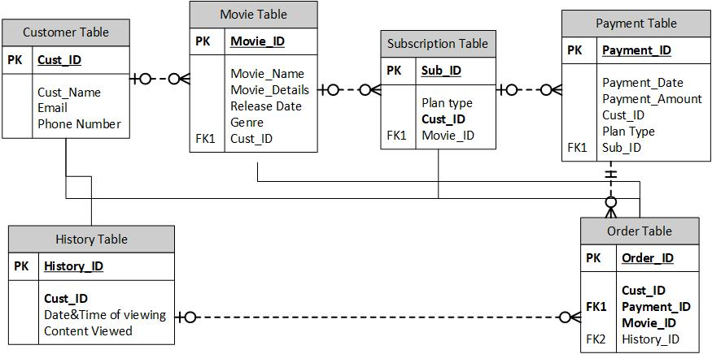

# **APA References**

* About Cineplex. Cineplex Corporate. (n.d.). Retrieved January 20, 2023, from <https://corp.cineplex.com/about>
* Cineplex Inc. (2022). Cineplex Inc. Annual report (2021). Annual report - 2021. Retrieved January 18, 2023, from <https://mediafiles.cineplex.com/investor-relations/management-investment-circulars/Cineplex_AR2021_digital.pdf>
* Cineplex Inc. (Canada) SWOT Analysis / SWOT Matrix. (2023, 01 23). Retrieved from EMBA pro: <https://embapro.com/frontpage/swotcoanalysis/2723-cineplex-inc->
* Kourmentza, E. (2022, April 26). Business analyst job description. Recruiting Resources: How to Recruit and Hire Better. Retrieved January 20, 2023, from <https://resources.workable.com/business-analyst-job-description>
* Williams, K. (n.d.). Retrieved February 13, 2022, from <https://study.com/academy/lesson/project-team-member-roles-responsibilities.html>
* *The global standard for business analysis*. The Global Standard for Business Analysis. (n.d.). Retrieved January 27, 2023, from <https://www.iiba.org/special-pages/the-global-standard-for-business-analysis/>
* Landau, P. (2022, December 14). *Project scope statement: Include these 7 things*. Project Manager. Retrieved January 27, 2023, from <https://www.projectmanager.com/blog/project-scope-statement>
* Maritalo, M. (n.d.). *Project Management and Business Analysis*. Retrieved January 27, 2023, from <https://www.pmi.org/learning/library/project-management-business-analysis-6410>
* Obrien, K. (2014, April 22). *Ba approach template - secrets to start a project the right way!Kai*. The BA Coach : Advancing Business Analysis & Agility. Retrieved January 27, 2023, from <http://www.bacoach.com/business-analysis-approach-template-secrets-to-start-a-project-the-right-way/>
* Ray, S. (2022, December 9). *A quick guide to project charters*. ProjectManager. Retrieved January 27, 2023, from <https://www.projectmanager.com/blog/project-charter>
* Stobierski, T. (2021, September 29). *How to create a stakeholder engagement plan*. Northeastern University Graduate Programs. Retrieved January 27, 2023, from <https://www.northeastern.edu/graduate/blog/stakeholder-engagement-plan/>
* Amirtham, V. (2023, February 17). What is pay per view? A full meaning of PPV &amp; How Does Work? CONTUS VPlayed Blog | The Future Trends &amp; Technologies of Video and Audio Streaming. Retrieved February 24, 2023, from <https://www.vplayed.com/blog/what-is-pay-per-view/>
* Asana. (n.d.). Business Requirements Document Template: 7 components [2022] • asana. Asana. Retrieved February 24, 2023, from <https://asana.com/resources/business-requirements-document-template>
* Rajkumar, B. (2023, February 14). How to build, Launch &amp; Grow A video streaming business in 2023? CONTUS VPlayed Blog | The Future Trends &amp; Technologies of Video and Audio Streaming. Retrieved February 24, 2023, from <https://www.vplayed.com/blog/how-to-start-video-streaming-business/>
* Colby, S. (2021, February 16). Pros and cons of big Bang vs phased rollout. HRchitect. Retrieved April 7, 2023, from [https://hrchitect.com/pros-and-cons-of-big-bang-versus-phased-](https://hrchitect.com/pros-and-cons-of-big-bang-versus-phased-rollout/) [rollout/](https://hrchitect.com/pros-and-cons-of-big-bang-versus-phased-rollout/)
* GEEKS FOR TECH. (2021, February 19). The challenges of deploying real-time streaming platforms. Medium. Retrieved April 7, 2023, from [https://medium.com/geeks-for-tech/the-](https://medium.com/geeks-for-tech/the-challenges-of-deploying-real-time-streaming-platforms-2b7fa8245b17) [challenges-of-deploying-real-time-streaming-platforms-2b7fa8245b17](https://medium.com/geeks-for-tech/the-challenges-of-deploying-real-time-streaming-platforms-2b7fa8245b17)
* Khrupa, A. (2023, January 6). Media Streaming Testing: Process, challenges, and automation potential. TestFort Testing &amp; QA Company. Retrieved April 7, 2023, from [https://testfort.com/blog/media-streaming-testing-process-test-cases-challenges-and-](https://testfort.com/blog/media-streaming-testing-process-test-cases-challenges-and-automation-potential) [automation-potential](https://testfort.com/blog/media-streaming-testing-process-test-cases-challenges-and-automation-potential)
* Stoll, J. (2022, November 21). Global content spend of streaming companies 2026. Statista. Retrieved April 7, 2023, from [https://www.statista.com/statistics/1248339/content-spend-](https://www.statista.com/statistics/1248339/content-spend-media-streaming-companies-worldwide/) [media-streaming-companies-worldwide/](https://www.statista.com/statistics/1248339/content-spend-media-streaming-companies-worldwide/)